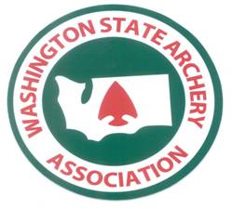
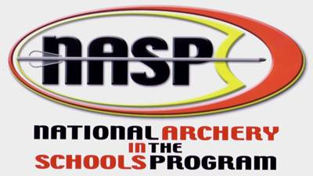
“Archery – On Target for Life”

Instructor Training

Saturday Nov 17th, 2007

WHERE: Central Washington University
Walnut and E 14th Ave.
Nicolson Pavilion, Parking Lot Q 14
Ellensburg, WA 98926

WHEN: Sat. Nov 17th, 2007 8:00 AM to 4:00 PM (Please arrive early)

COST: $60.00

WHAT TO EXPECT: Basic Archery Instructor training.

We will have a very full agenda, covering archery range setup and safety, archery shooting technique, coaching positions and practical shooting skills.

Our day will be compressed because of other commitments for the space that we are in. So, please be prompt and ready to participate when you arrive. Dress for casual exercise.

We will have breaks and lunch on site to save time. Bring a sack lunch or we can have a runner order out for sandwiches and share cost.

TO REGISTER: Contact Dave Mack at 360-577-6301 or ddmack@comcast.net

DIRECTIONS: From the west, take Interstate 90 to Exit 106, follow 90 Business Loop along Cascade Way, W 8th Ave to N A St. Turn left on N A St and go north to E 14th St, turn right and go east on 14th St to Nicholson Pavilion.

From the East, take I-90 exit 109, the surface street will be Canyon Rd., going north (Rt) on Canyon Rd it turns into S Main St and then N A ST, continue north to E 14th Ave, turn right and go approximately 4 blocks to Nicholson Pavilion.

